Best Practice Example
SHARING AN IDEA THAT WORKS!
THE POLIO PLUS SOCIETY

The PolioPlus Society is a program currently being used by the Districts throughout the Rotary World

What is the PolioPlus Society? In an effort to increase sustainable giving, the PolioPlus Society (PPS) was formed to encourage Rotarians to commit to a minimum of $100 per year to the PolioPlus Fund until polio is eradicated from the face of the earth. Society members receive a special PPS pin, an End Polio Now bracelet, and a certificate.

The original concept came in 2012 from Rotarian Harriett Schloer of Bend High Desert Rotary in Oregon, along with then DG Dell Gray of District 5110. Current PolioPLus Chair Nelson Maler reports they currently have nearly 800 Rotarians who have signed up as members of the PolioPlus Society. That means that they can count on those PPS members giving a minimum of $80,000 annually, which becomes their baseline for each and every year thereafter until the virus is gone!

How to donate to PolioPlus thru the PPS:
- Go to my.rotary.org/donate and click on “Polio Fund”.
- We encourage Rotarians to join PolioPlus Direct (the recurring option), signing up for automatic giving with a credit card. $10 (or more) per month will qualify them for the society.
- Of course, they can also donate through their club.

Administration of program – The program will be administered by the individual District PolioPlus Chairs, or their designate.

Some PPS Pin examples
PolioPlus overhead costs are the PPS pins and the End Polio Now wristbands.
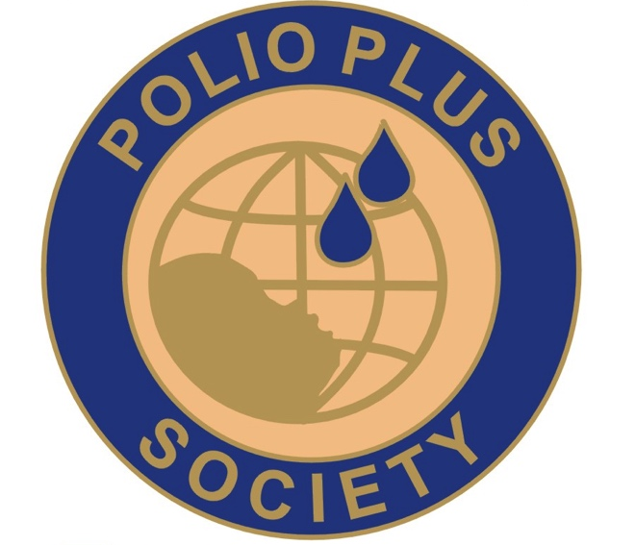
The pins conform to RI’s standards and are currently being supplied by Rotarian Dwight Perry of “Perry’s Creative Promotions” at 510-582-5366 or Dwight@pinthis.com Costs are as follows:
250 - $1.65 each
500 - $1.40 each
1,000 - $1.25 each
Plus sales tax and shipping. For Magnetized pins, add $.40 Districts could consider consolidating their orders to take advantage of quantity discounts.
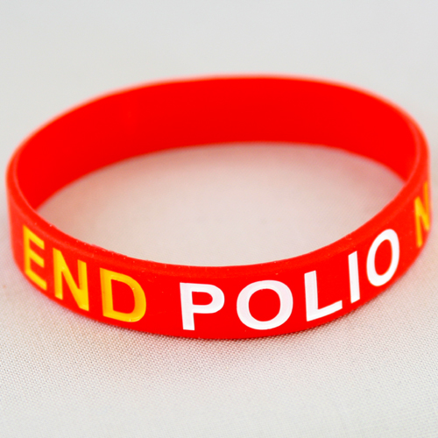
End Polio Now wristbands, should you decide to include them, are $1 each in quantities of 100 or more from Russell Hampton. Certificates can be printed by each district utilizing the supplied template at no cost other than paper.
If it’s in your Zone’s budget, you might consider offering districts a “Starter Kit” of 50 pins and wristbands, as an incentive to join the program.

